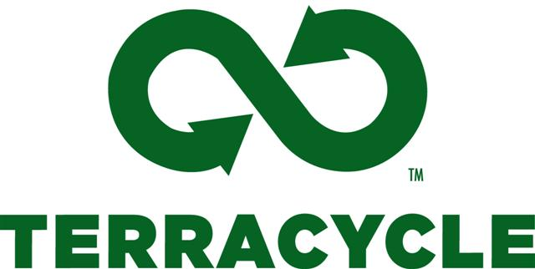

Current Collection Streams

Drink Pouch Brigade: We accept any kind of brand of drink pouches. We do not accept juice boxes.

Home Storage Brigade: We are collecting any used Ziploc® bags and containers, or like products – any size, any brand.

Candy Wrapper Brigade: We will accept any brand and size candy wrappers. Please keep in mind that we donate $0.02 for all candy wrappers. We do not accept candy boxes or gum packaging. NOTE: This includes the larger bags that the fun size candy bars come in.

Scotch Tape Brigade: We accept any brand and any size plastic tape dispensers and cores.

Cookie Wrapper Brigade: We are collecting all brands and sizes of cookie wrappers. NOTE: This includes 100 calorie packs!

Spreads Brigade: We accept any brand and any size of spread tubs and lids. Examples include butter, margarine and cream cheese spread tubs.

Scott Brand Brigade: We accept any brand and any size of outer plastic wrapping from paper products, such as towels, toilet paper, napkins, paper plates, moist toilet wipes (such as Cottonelle brand wipes) products.

Elmer's Glue Crew Brigade: Only Elmer’s! We accept any size Elmer’s brand glue sticks and plastic glue bottles when you send in a minimum of 250 empties.

Energy Bar Wrapper Brigade: We will accept any foil lined energy and granola bar wrapper. We are currently collecting only energy bar wrappers, not candy wrappers. NOTE: This includes Fiber One bars and Quacker Oats granola bars.

Tortilla and Tostada Bag Brigade™: We accept any tortilla and tostada packaging.

Wait Listed Collection Streams
These brigades are currently full and we have been placed on the Wait List.

Yogurt Brigade: We will accept any size Yogurt container that will nest (neatly stack).

Chip Bag Brigade: We accept any empty brand or size chip bag.

Cork Brigade: We accept all natural and synthetic corks.

Lunch Kit Brigade: We accept any brand and any size lunch kit packaging. We will accept all parts of the lunch kit, excluding the cardboard.

Colgate Oral Care Brigade: We accept any brand used toothpaste tubes, toothbrushes and plastic toothbrush packaging, excluding cardboard.

